Alaska + Yellowstone 2017

Termine
DO 27. Juli – DO 17. August = 3 Wochen
Hinflug 27. Juli
Rückflug 16./17. August

Alaska

Route
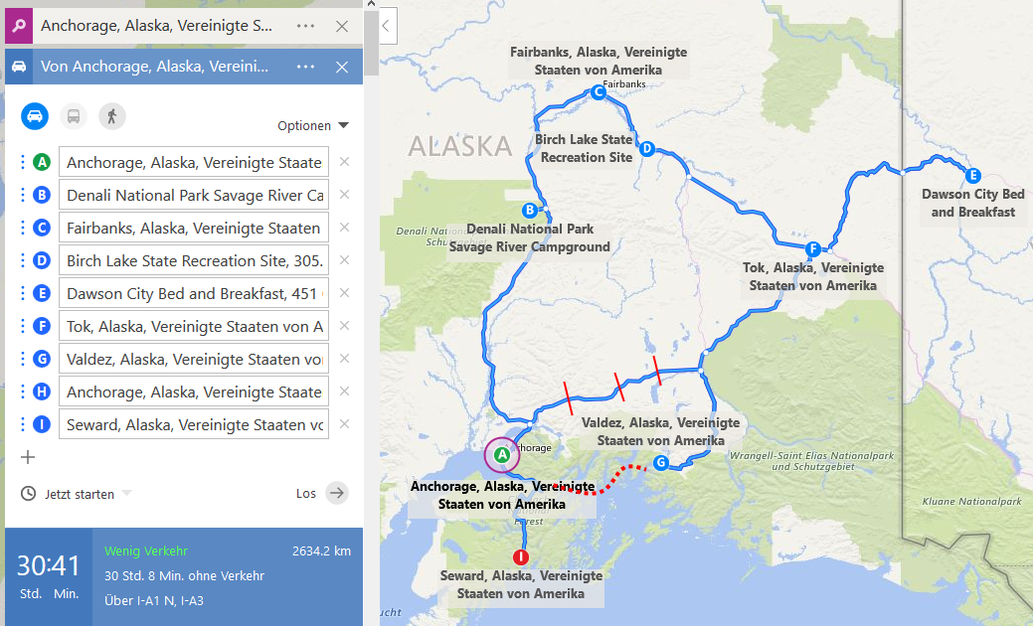

Fahrzeug
http://www.northwestvancampers.com/vans/equipment-for-hire/

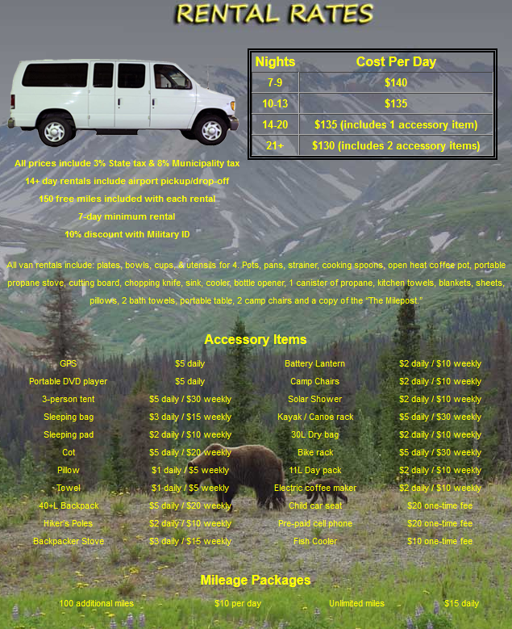
Hi there, we're a couple from Switzerland and plan to enjoy Alaska with a camper van in summer 2017. We came across your website and were amazed by your vans and the customer reviews on Google. This is exactly what we were looking for!
We are 36 and 31 years old, but as Swiss residents we do not have a US auto insurance policy. Do you have options for this?
We would arrive in Anchorage on Thursday Evening already and spend Friday in the city itself to relax after the long flight. We'd like to pick up the van on Saturday morning, by some stuff and continue to Denali NP for camping. After our camping trip (10 days, 9 nights) we plan to to fly further on Monday, August 7 in the early afternoon.
We have camping experience from US and Canada and would love to discover the North now.
Looking forward to hearing from you!
Best regards,
Gerry & Stephanie

(03.10.2016, 20:50)
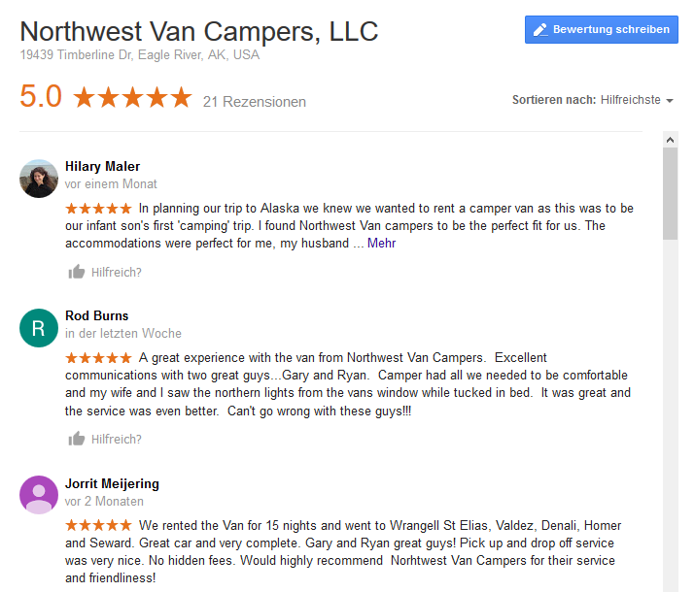

Yellowstone

Route
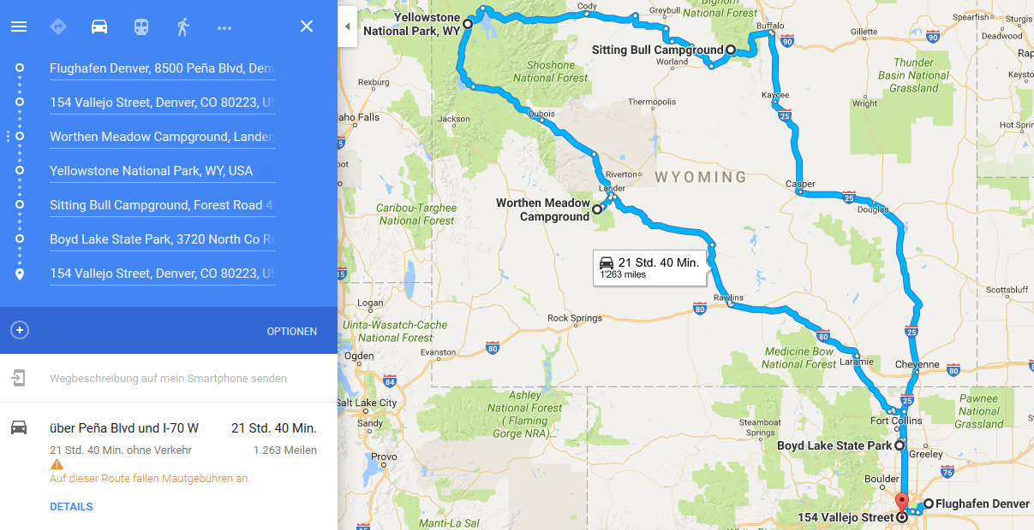

Karte Yellowstone NP

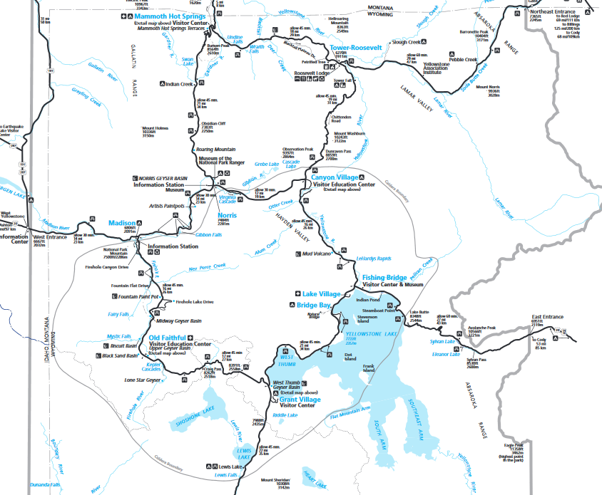

Fahrzeug
Variante 1 Tag Denver:
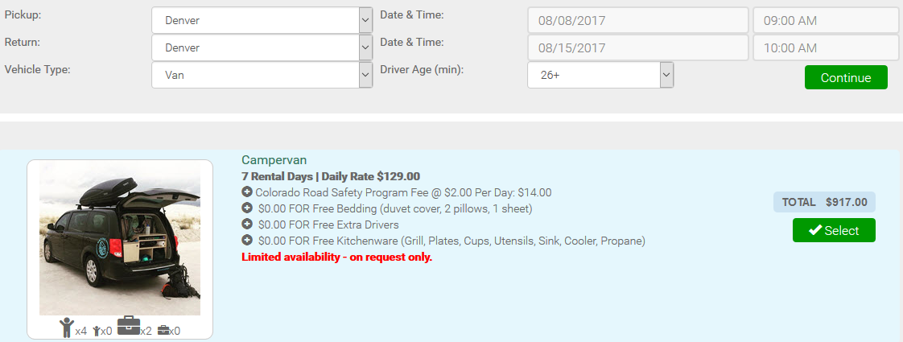
Alter Preis:
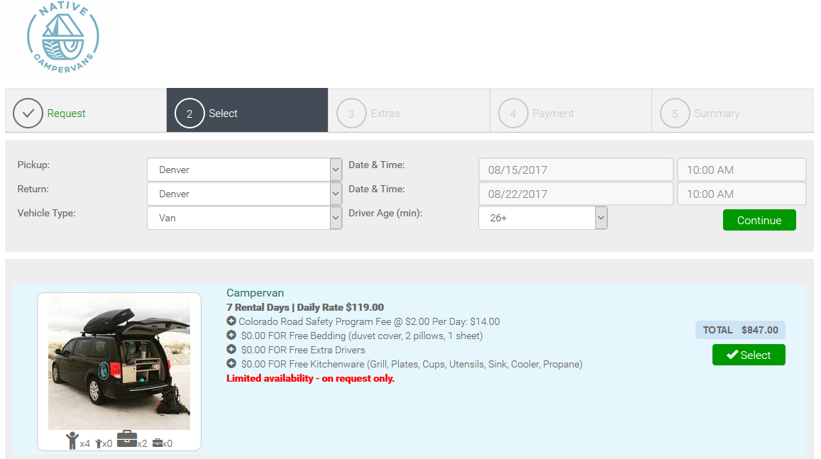
Neuer Preis:
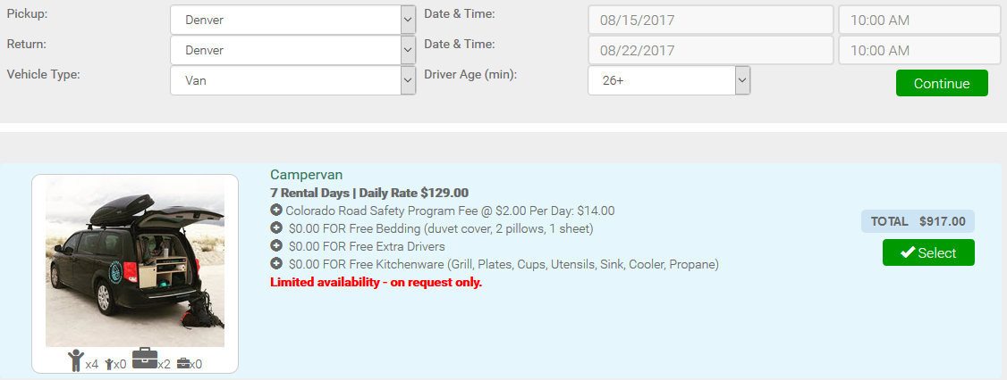
Variante Fz-Abgabe plus Flug am gleichen Tag:
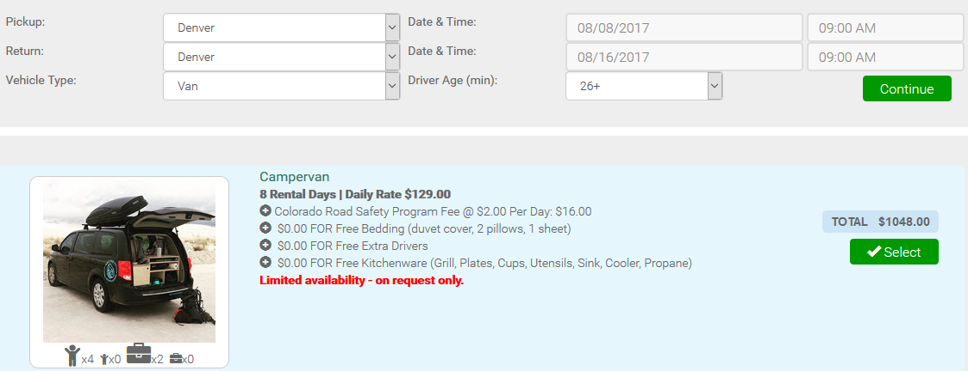

Flüge

Intercontinental
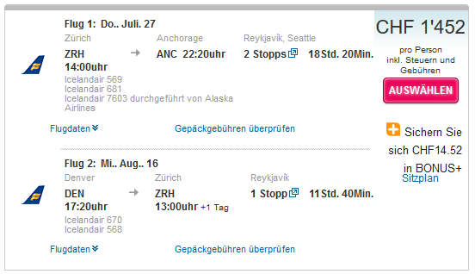
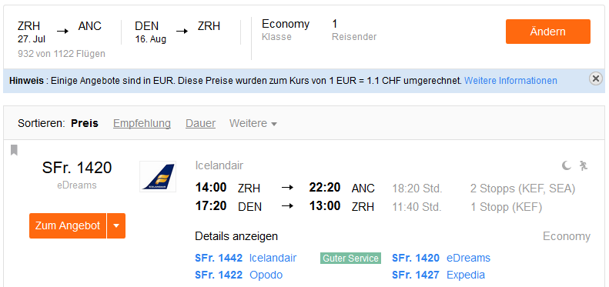
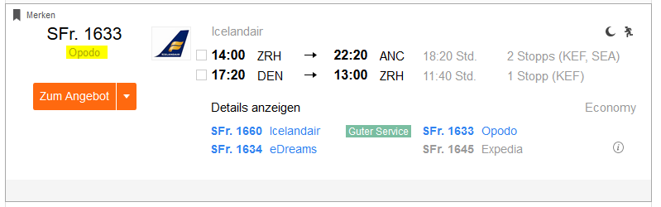

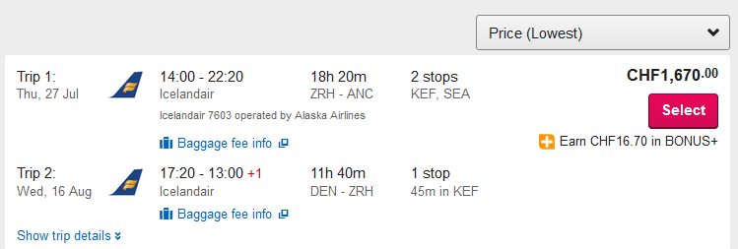
Variante 1 Tag Früher:
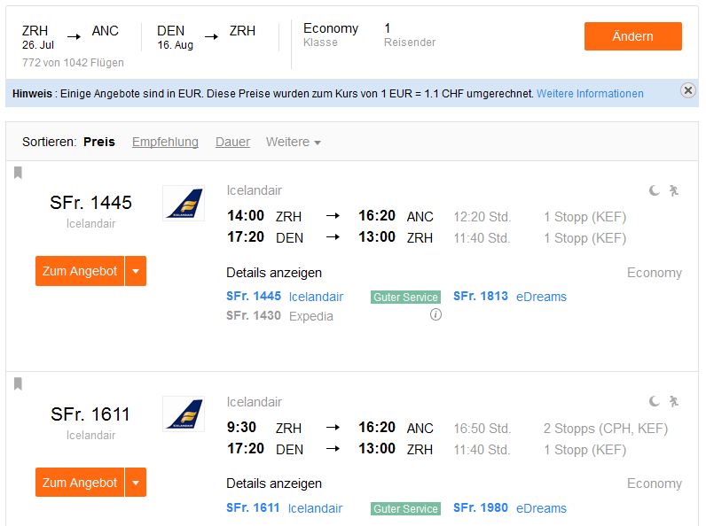
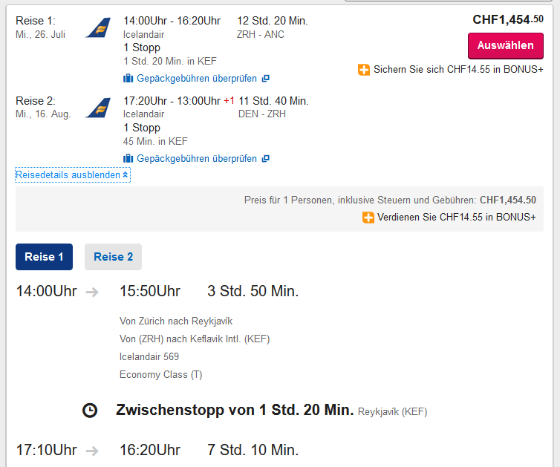
14.10.2016
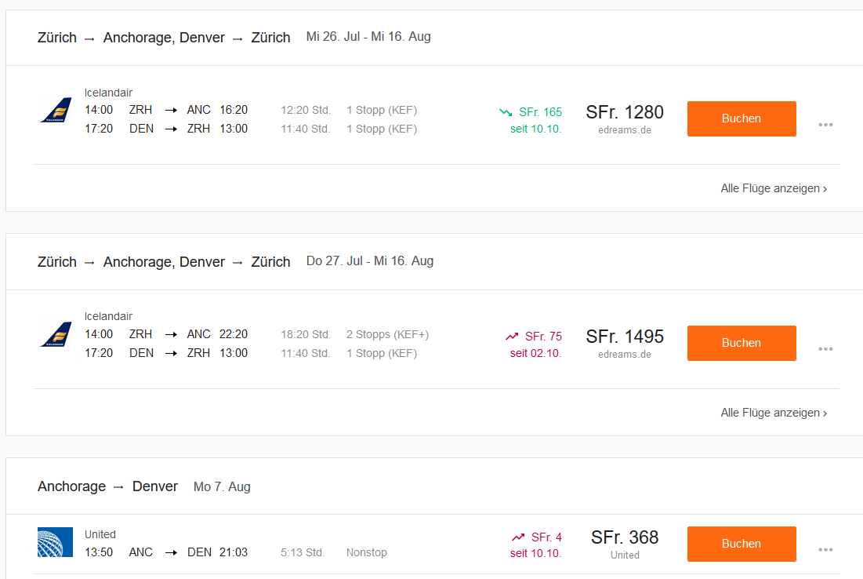
16.10.2016
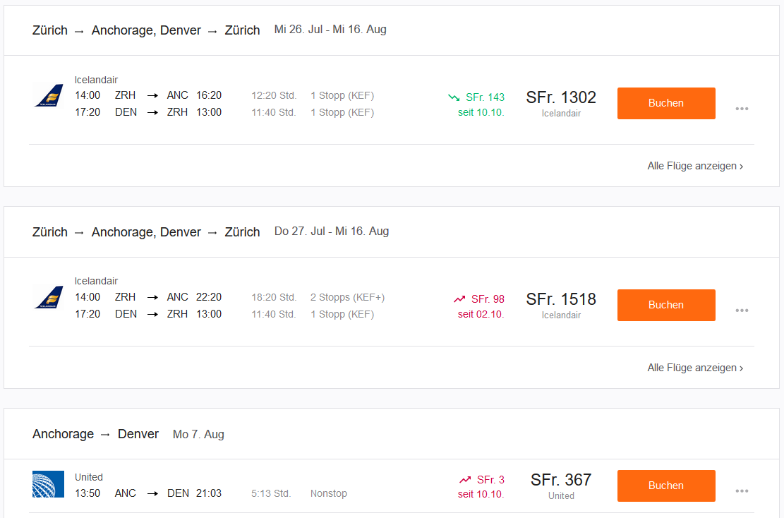
18.10.2016
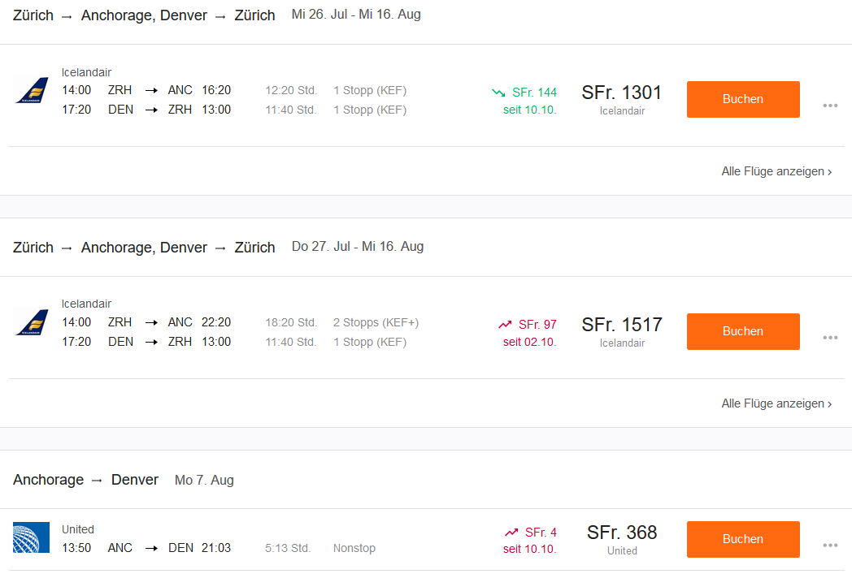
19.10.2016
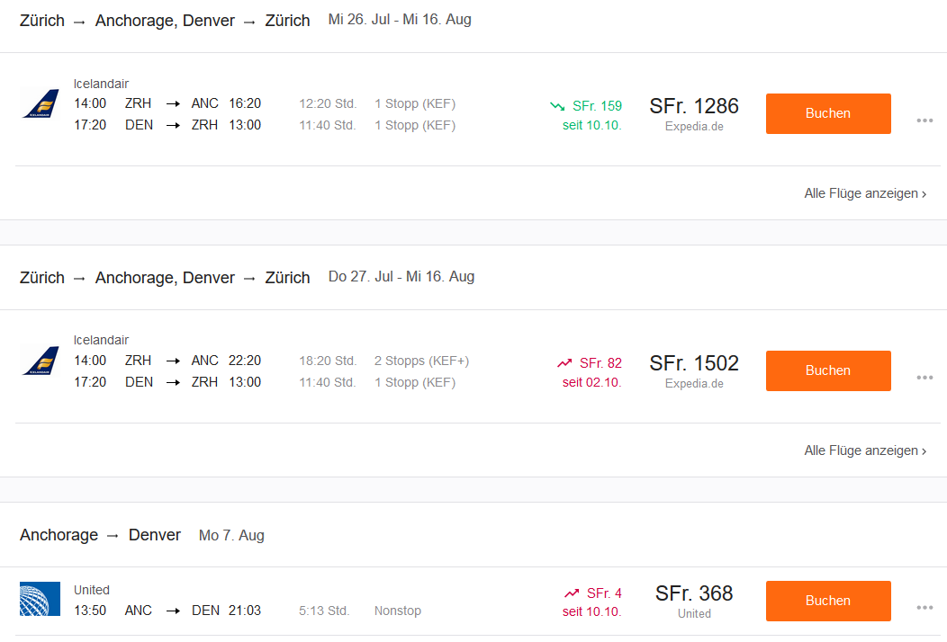
22.10.2016
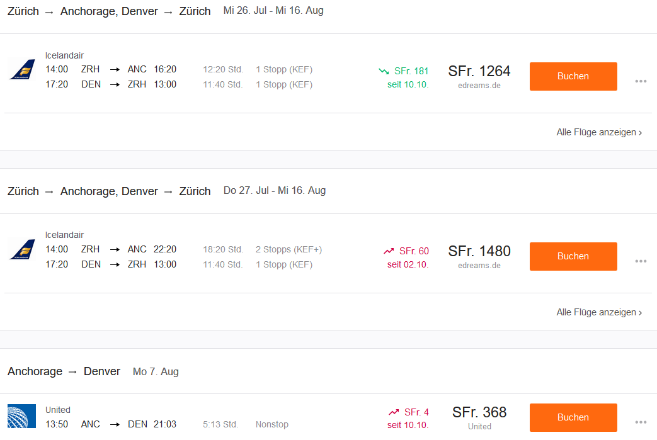
25.10.2016
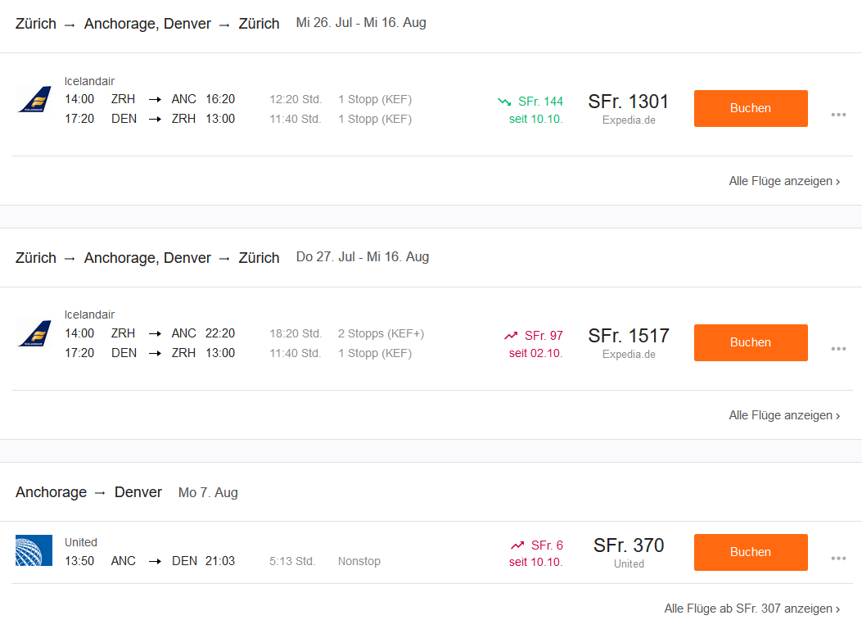
01.11.2016
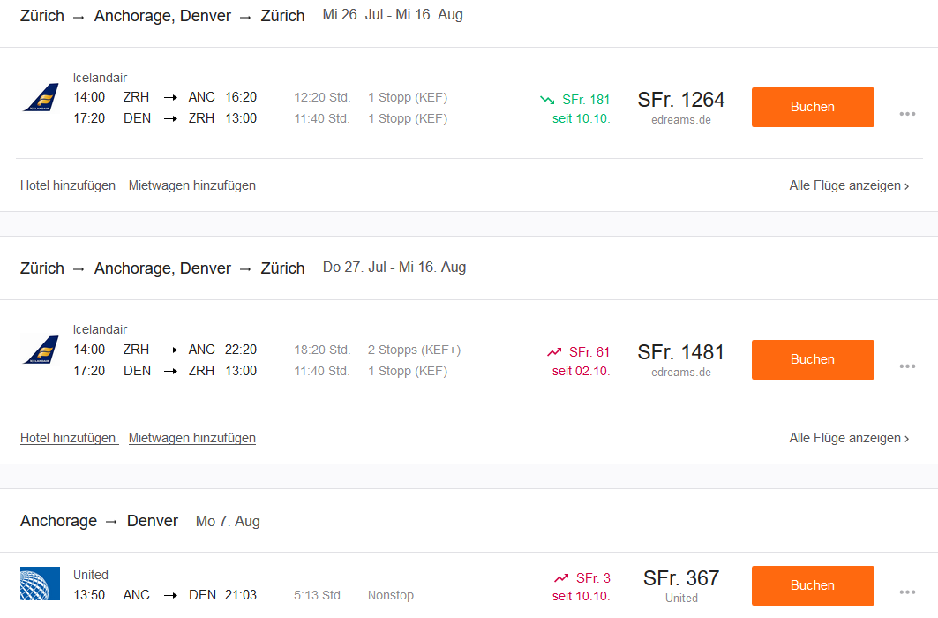

Anchorage – Denver
