Sommerferien 2016 – Evaluation

Termine
FR 04. August – SO 27. August = 3 Wochen
Hinflug 04. August
Rückflug 25. August

USA – Colorado & Yellowstone

Overview
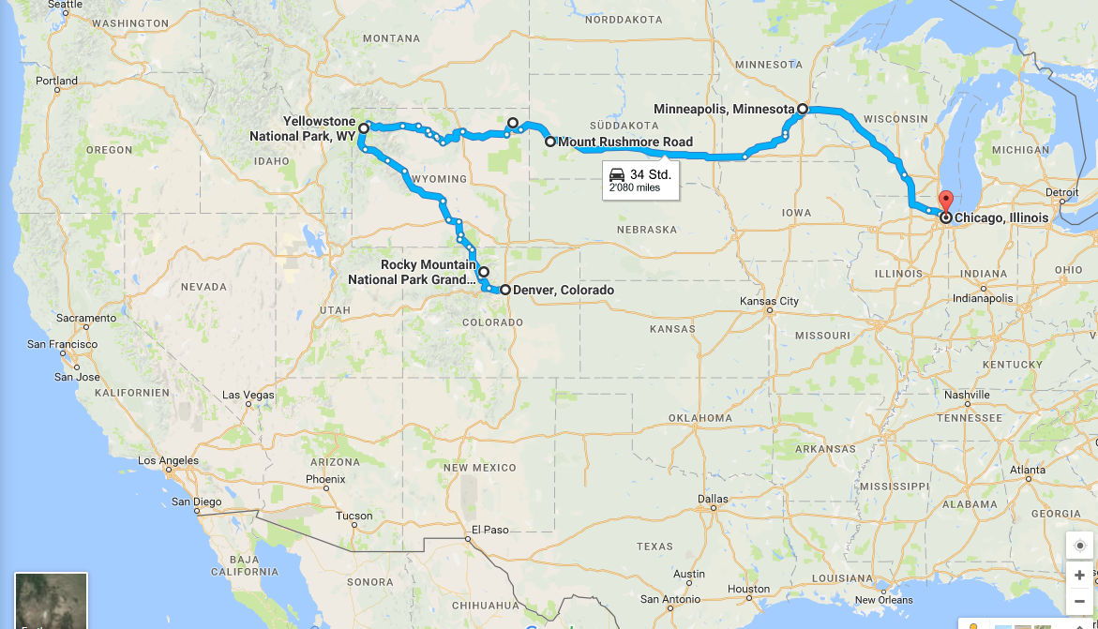

Flüge
ZRH – Denver – Chicago – ZRH
Ebookers:
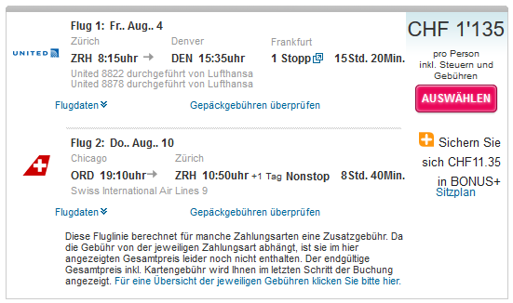

Alaska & Yellowstone

Overview Alaska
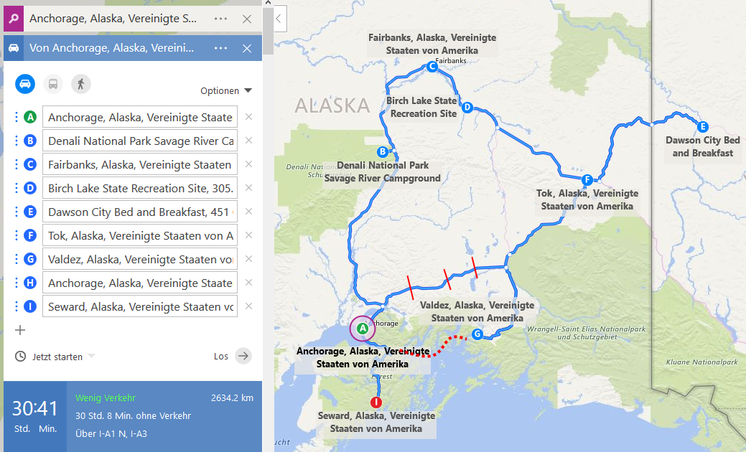

Overview Denver / Yellowstone
Variante «Gross» (Zeitaufwändig)
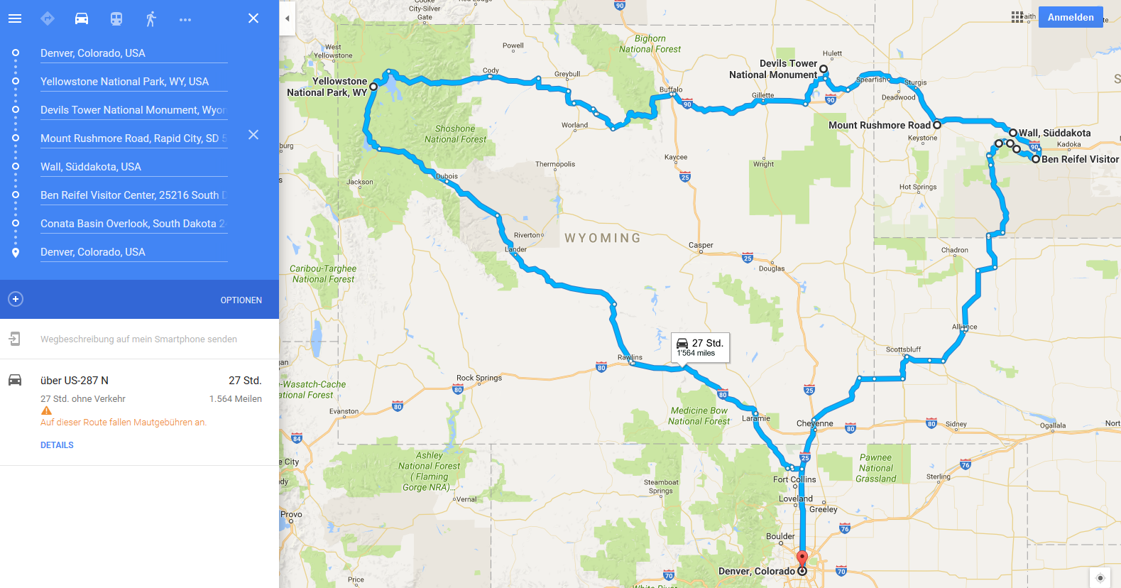
Variante «Klein»
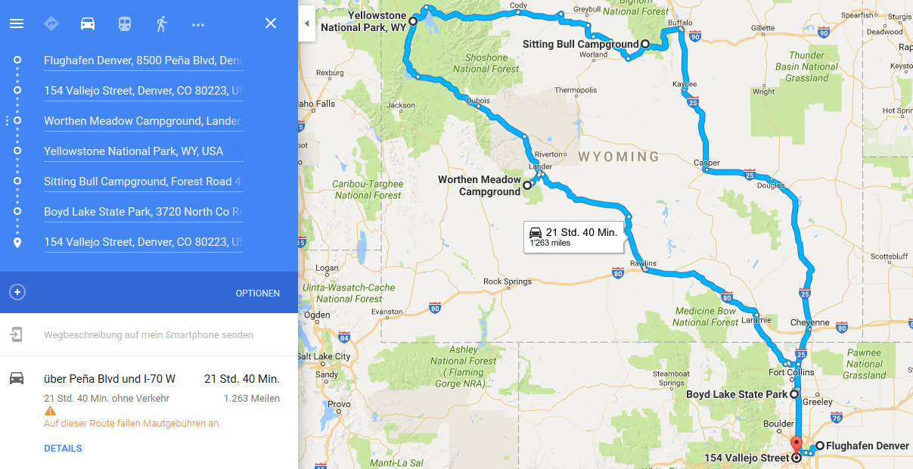

Overview Yellowstone NP

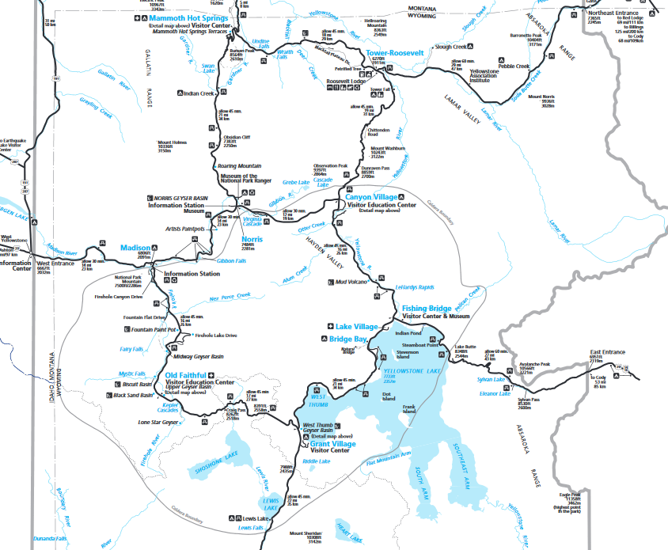

Overview Badlands NP

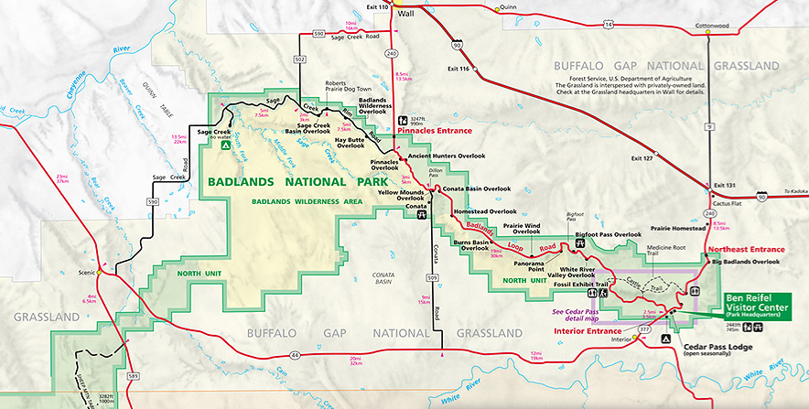

RV vs. Auto

Alaska

Cruiseamerica.com:
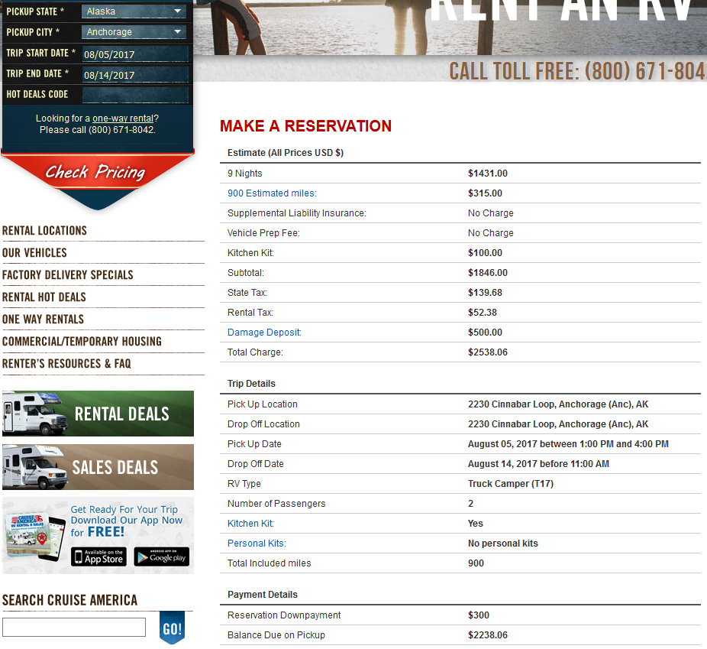

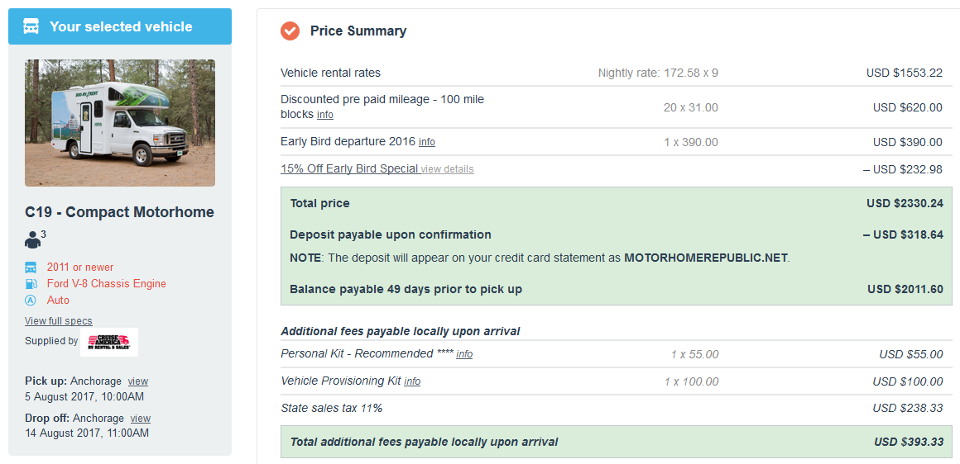
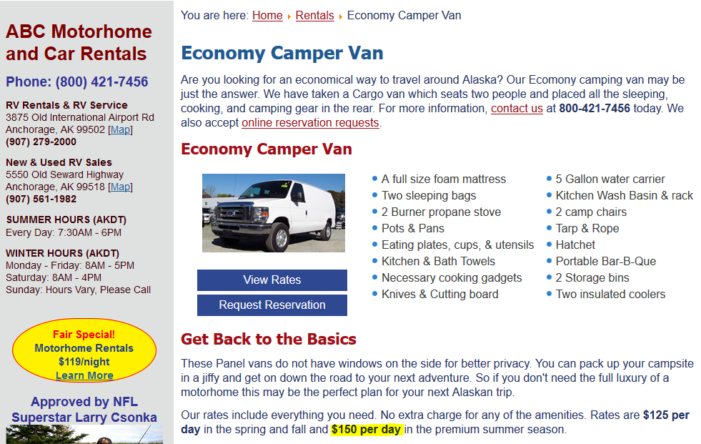
9 x 150 = $ 1’350
Gonorth-alaska.com
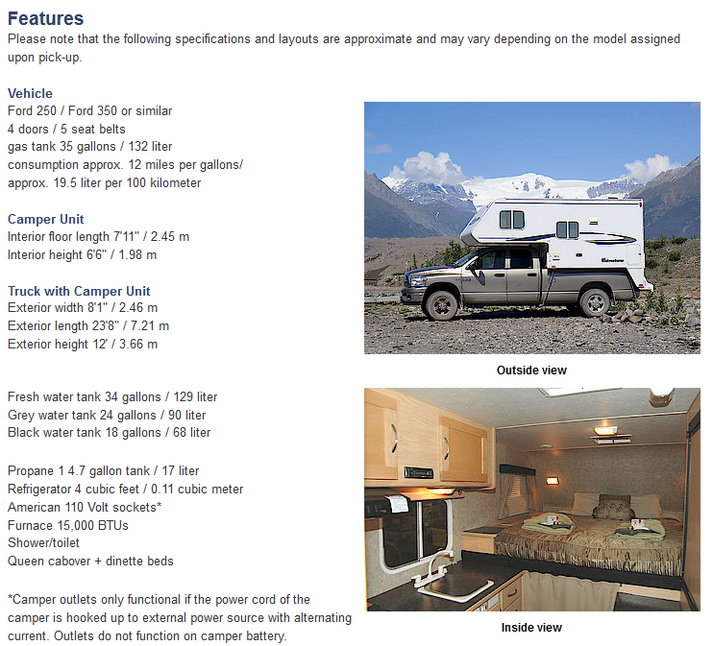
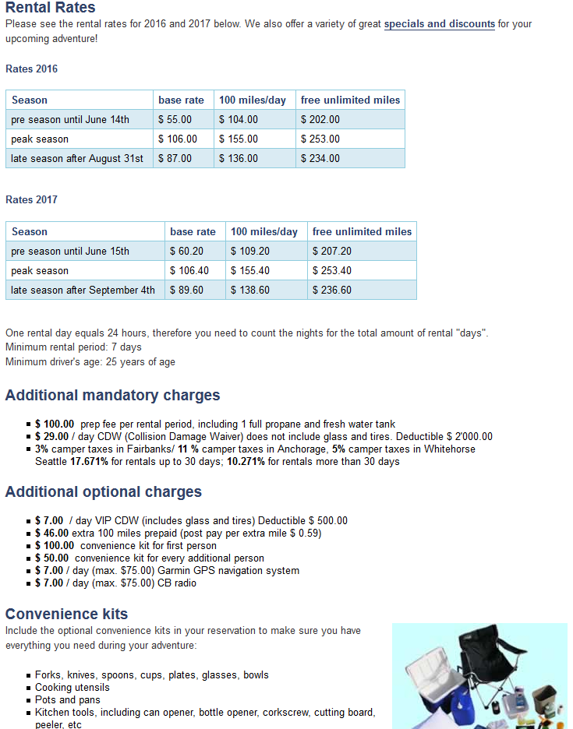
10% early bird discount on base rate…
http://www.northwestvancampers.com/vans/equipment-for-hire/
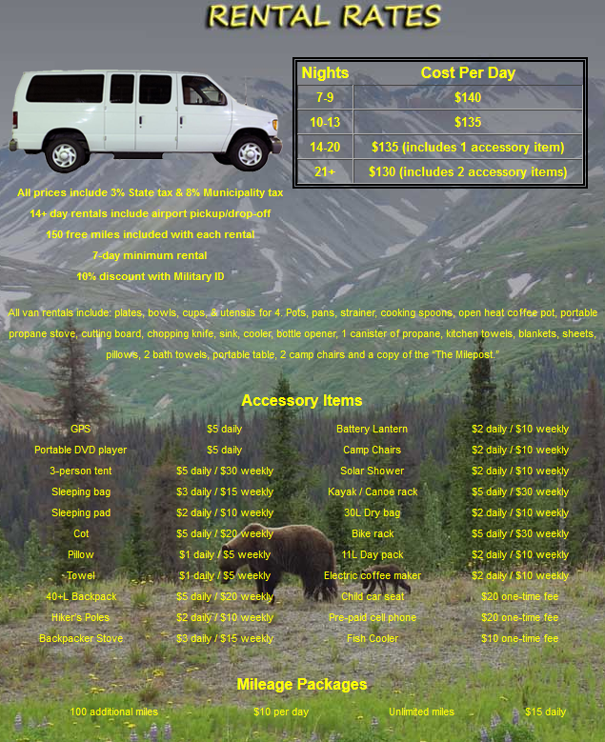
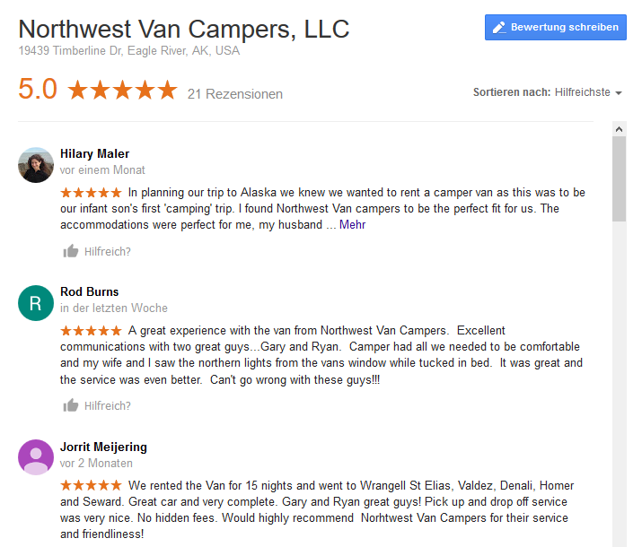
http://alaskarentacar.net/

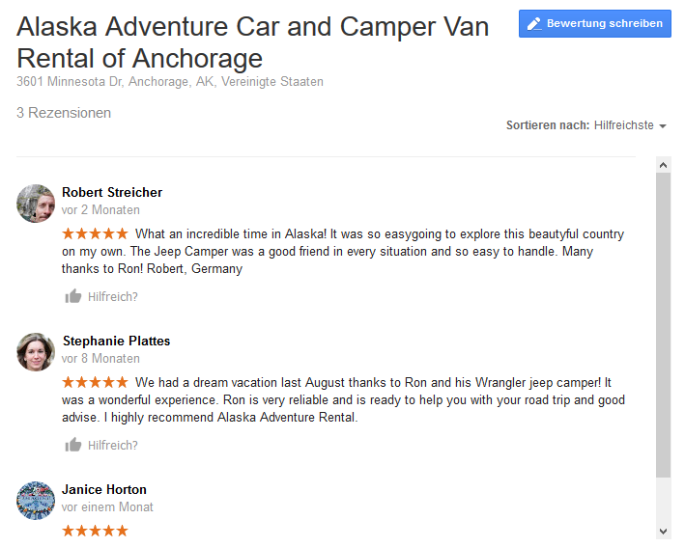

Carrentals.com

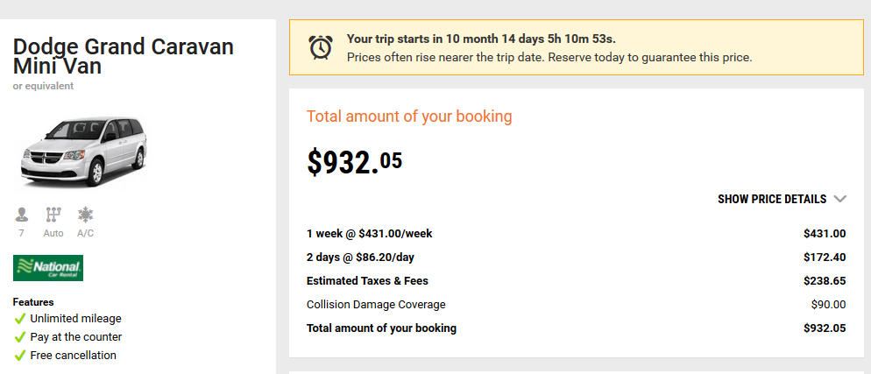

Denver / Yellowstone:
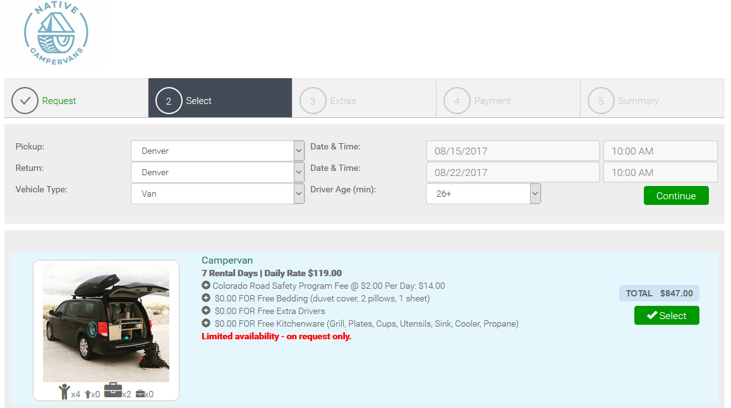


Flüge



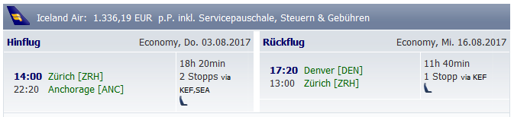
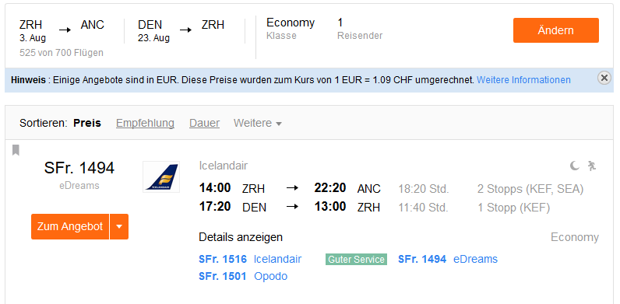
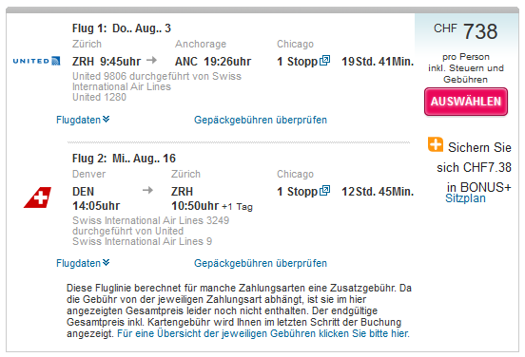
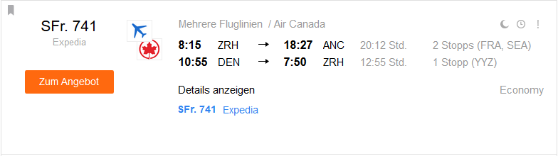

Variante Salt Lake City



